Quick Guide on Using Petstablished
- Once you have been added to the system you will receive an email on how to log in.
- After you are assigned to an application you will receive an email from Support@petstablished.com with a link to the application and also a PDF attachment of the application.
- Per the HOME VISIT PROCESS document, follow the steps to complete the application.
- During each part of the process note the findings under the appropriate section for that applicant. Once you have input your notes, “Mark Checklist Item Complete”
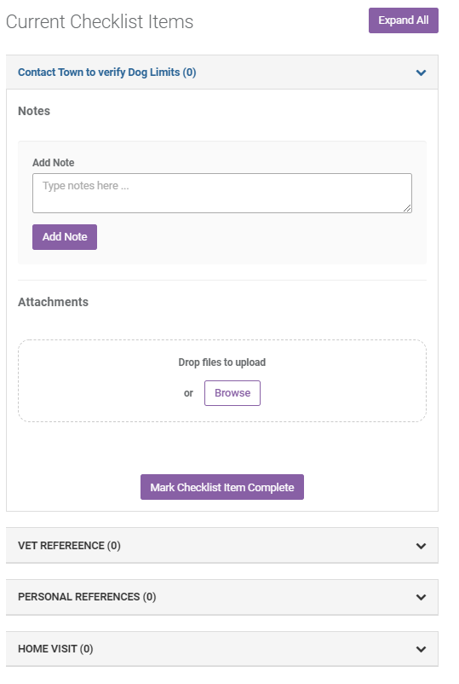
- If any application withdraws please “Archive” the application and make note of the reason why.
- If an application needs to be denied, please consult a member of leadership first and then once its agreed that the denial is valid then update the status to “Currently Denied”. An automatic email will be generated and delivered to the applicant. Make note of the reason for denial, be as detailed as possible.
- While working through the application you make change the Status using the drop down shown below.
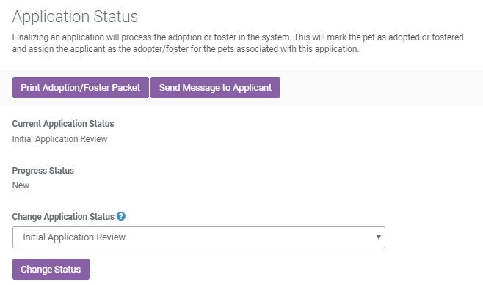

- If there are multiple people assigned to an application you can communicate using the “Application General Notes” section. When you enter a comment an email will go to the other people on the application to notify them of a change.
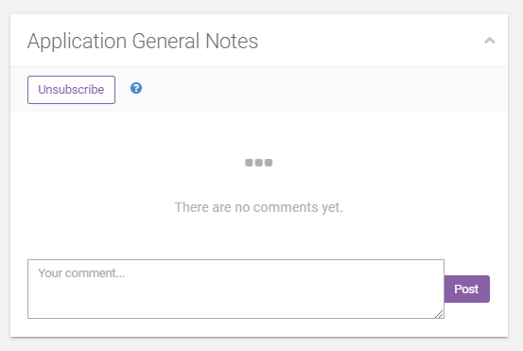

- If for some reason you need to update the applicants contact information that can be done from the screen below.
