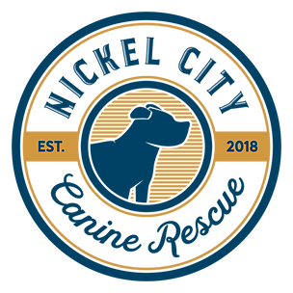 | Meeting minutes  April 28, 2020

Board Meeting

- Manuals/Documents
  - Meeting with all members of the rescue on an as needed basis
  - Questions/Concerns button on website.
  - Edit FAQS on website.
  - Combine manuals into one.

- Foster Applications
  - Add new questions
    - Have you fostered before?
    - What organization?
      - Reference check
    - Why did you leave?
    - Have you ever given up a dog?
  - Add to next month's agenda.

- Supplies
  - Look into getting a drop box.
  - Order martingales for the rescue and to sell.

- Legal
  - Google was emailed.
  - Bylaws
  - Dawn Castillo

- Retraining
  - Meet with foster/volunteer trainers
  - Refresh with everyone
    - Go over everything
    - Training everyday of the week
  - Foster
    - Make checklist
      - Comment section
      - Decompression
      - Expectations
      - Commitment
  - Upload Contract
    - Issues with S/N not being initialed
    - Write Venmo on top
  - Make training tab on website
    - Reference materials
    - Checklists
    - Jotform to send?
    - Photo of vaccine sheet
      - Where to document

- Litters of puppies
  - Beatrice DOB 3/27
    - 6wks- 5/8 or 5/9
    - 8wks- 5/23
  - Pinto DOB 4/7
    - 6wks- 5/19
    - 8wks- 6/2
  - Kierra DOB 4/16
    - 6wks- 5/28
    - 8wks- 6/13
  - Oreo DOB 4/12
    - 6wks- 5/26
    - 8wks- 6/7
  - Felicity DOB 4/28
    - 6wks- 6/9
    - 8wks- 6/21
  - Bottle Feeders DOB 3/26
    - 6wks- Vaccines administered by Clarke County 4/30
    - 8wks- 5/23
  - Post at 8 weeks and meetings at the office.

