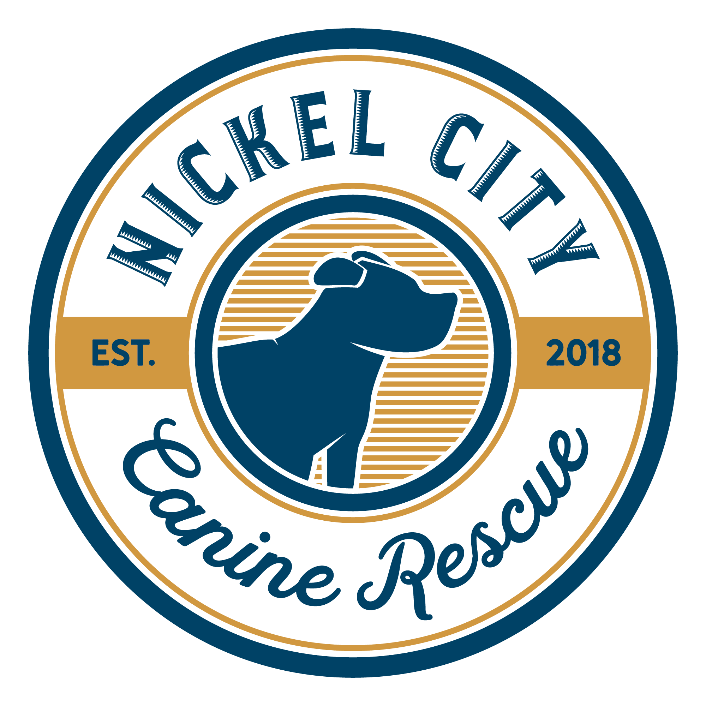

Nickel City Canine Rescue
How To Adopt Cheat Sheet

- Getting on a dog’s list
  - Be sure to check Facebook and the website often!
    - Dogs are added when our volunteers send bios and when we have the time to post. There is not necessarily any rhyme or reason.
    - Facebook tends to be updated before the website.
  - Message the Facebook page or send an email immediately once you see the bio of a dog you’re interested in
    - Please list the name on your application, dog you’re interested, and say that you’re already pre-approve
    - We limit each adopter to being on 3 dogs lists at a time
    - We go by the time stamps on Facebook messages and emails to keep things fair
    - Commenting on a photo will not get you on their list. You must message or email!
    - We do not take names until their bio is posted in the “meet our adoptable dogs” Facebook album or the website. We do not accept names based on preview posts.
  - It can be competitive depending on the dog and time of year. Please don’t get discouraged, the right fit will be out there!
    - Transports typically come every 2-3 weeks
    - Puppies are on a mandatory 10 day health hold upon arrival and adults on a 5 day health hold before they can start meet and greets
- Once you’re on a list
  - We take up to 5 names per dog
  - The foster will go through the list in the order in which we receive names
    - We do not disclose the order of interested applicants on the dog’s list
    - You may be on a list and not hear from the foster right away if the dog is still on the health hold or if there are people ahead of you
  - If the foster reaches your name, they will call, text, or email to set up a meet and greet
    - If you have pets the meet and greet will need to be at your home, if you don’t have other pets it may be at a mutual location
    - You have 24 hrs to decide if you would like to adopt after the meet and greet
- Questions about dogs
  - The dogs bio will include as much information as the foster provides
  - If you’re interested in knowing more about the dog, when the foster calls to set up a meet and greet they will be able to answer any questions you may have

