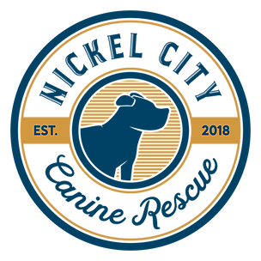 | Meeting Minutes  March 30, 2020

Board Meeting

- Bylaws
  - Positions
  - Need to make an appointment with the lawyer to edit bylaws.
- Merchandise
  - Leave the current merchandise sale site up.
  - Look into Spot of Tee for a future option.
- New Contact Cards
  - Order new contact cards to put in foster/volunteer folders. This will include updated contact information for the board and leadership.
- Collars
  - Order a hook.
- Crate tags
  - Ideas for new crate identification:
    - Dog tags
    - S Rings
    - Marker
    - Stencils and spray paint for bottom tray.
- Fundraisers
  - Lottery board
    - Need Jotform
  - Beer Blast
  - May basket
    - Flag/Memorial Day
- Website
  - Make a members section
  - Remove quotes
  - Tentative fundraisers
  - Apply now button
- Access to sites
  - We currently need to change/get access to the following
    - Stripe
    - Mailchimp
    - NYS Charity
    - Netsuite
    - Volunteer WNY
- Long Term Goals
  - Office Space
  - Savings
  - Take in more pregnant dogs
  - Microscope
- Retraining
  - Volunteer/Foster retraining with updated policies and procedures.
  - Update expectations sheet
  - Fosters must call the name sent to them before making a decision not to meet.
- Vet visits
  - Discussed medical
  - Lollypop Farm for potential Spay/Neuter

